Vor und Nachnahme:

Judah Holanda Correia Lima

Computer Engineer

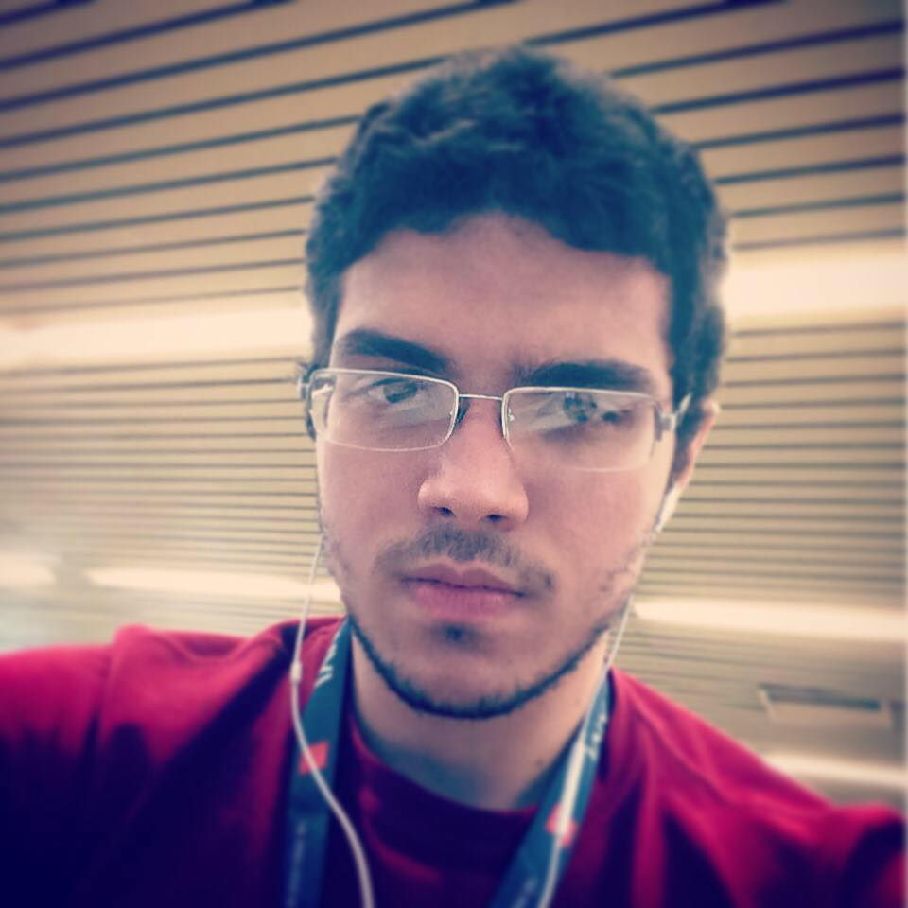

0 PERSÖNLICHE MEINUNG

I'm a 23 years old Computer Engineer from Fortaleza (Brazil). Currently I work as a Game Developer (C# Programmer) at Valente Studios. I love everything that has to do with Computers so that means: Programming, Gaming, Designing and etc.  
I have 1.5 years of experience working as a mobile/web developer and some more working on projects including firmware, hardware and even physics, but now I’m ready for visiting other countries and work anywhere! I love working with people, especially if they have the same passion I have for what they do.

± BERUFLICHE QUALIFIKATION

-Major in Computer Engineering at Universidade de Fortaleza – UNIFOR  
- Circuit Board Design with Altium  
- Programming in Java  
- Microcontrollers PIC 18 - Programming in ANSI C  
- Mobile Devices Programming (IOS)

®MOBLIE

Mobile Devices Programming:  
- IOS (objetive-C)  
- Android (Java)

- Ionic

Contact

:judahholanda7@gmail.com

µ :<http://judah.me>

µWEB

Web Programming:  
- Java  
- PHP   
- Node (JavaScript/TypeScript)  
Web Design:  
- CSS3  
- HTML5  
Web Script:  
- JavaScript  
-TypeScript

iSOFTWARE

Programming Languages:  
- C (ANSI)  
- C++  
- C#  
- objetive-C  
- Java  
  
Databases:  
- MySQL  
- PostgreSQL  
- Oracle

gHARDWARE

Microcontrollers and Microprocessors:  
- Freescale (ARM/HCS12)  
- Microchip (PIC)  
Development Platforms:  
- BeagleBone  
- Raspberry  
- Freedom  
- KWIKSTIK  
Circuit Board Design:  
- Altium  
HDL:  
- Verilog(Basic)  
- VHDL(Basic)

}SPRACHEN

- Portuguese (Native Speaker)  
- English (IELTS 6.5 – Studied in California)  
- Spanish (Medium)

¬BERUFLICHE ERFAHRUNGEN

- Java Programmer at IVIA

- Unifor (Intern Supervisor/Programmer - LabView, Java, MySQL) - 4 months

- IVIA (Trainee Programmer - Java, C #, Typescript) - 4 months

- G4Flex (Intern Programmer - Java Web, Android, iOS) - 1 year and 9 months

- Unifor (Intern Programmer - FIRMWARE Freescale HCS12) 1 year

Hobbies

- Drawing

- Painting

- Gamming

- Programing

- Music

- Playing the guitar

PERSÖNLICHE DATEN

Staatsangehörigkeit: Brazilian

Familienstand: Single

ANSCHRIFT

An der Tongrube 12

99817 Eisenach

Telefonummer: 03691/70 33 548